Annual Progress Report

United Nations Development Programme

Project Samoa CARES: Building Sustainable, Resilient Communities Together

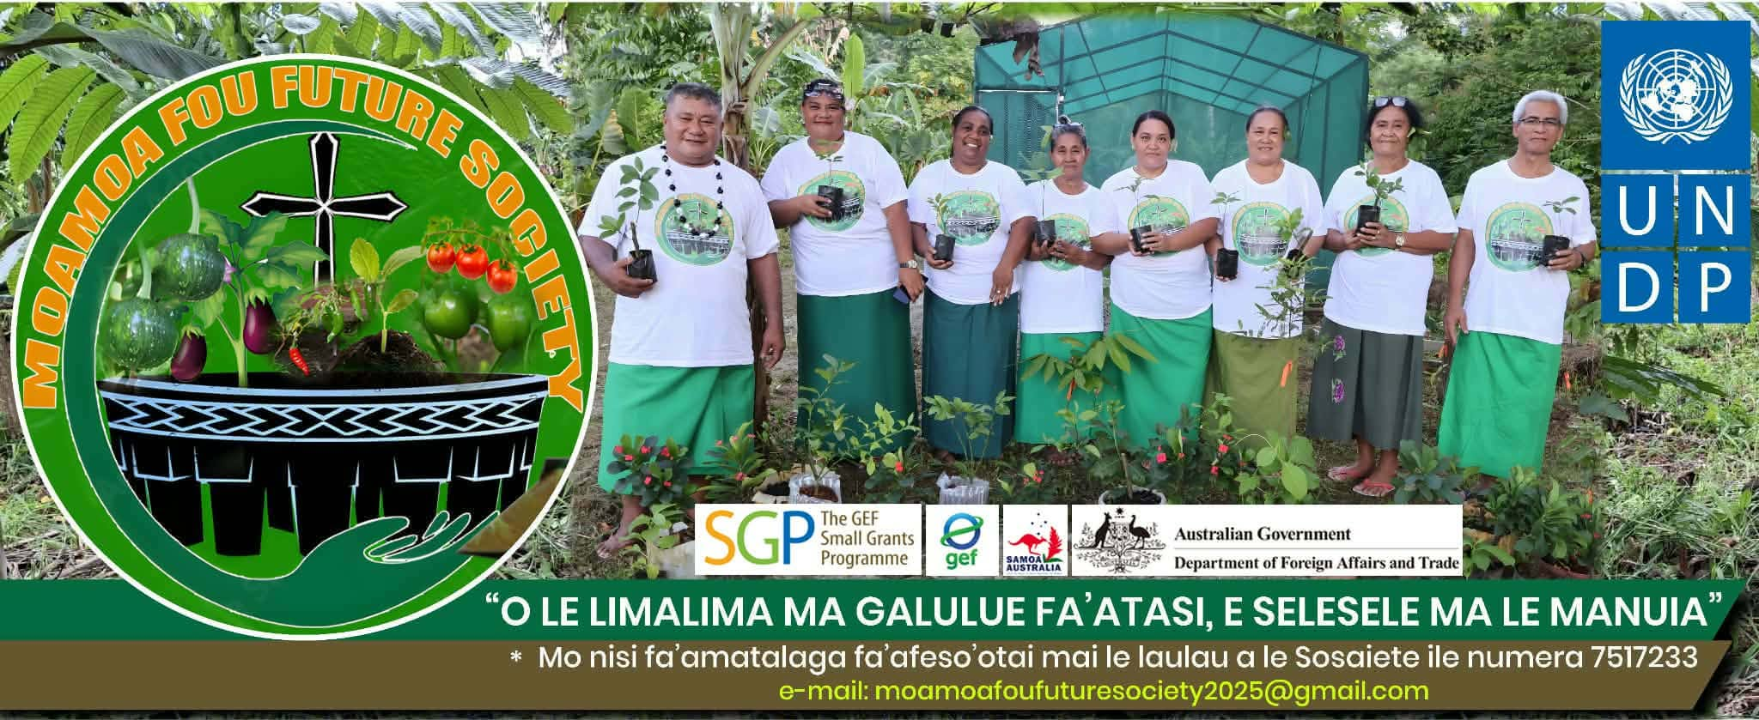

Reporting Period | June -December 2025  January 2026- June 2026
Donor | DFAT
Country | Samoa
Project Title | Samoa CARES: Building Sustainable, Resilient Communities Together
Project ID  (Atlas Award ID)  Outputs  (Atlas Project ID and Description)  Strategic Plan and/or CPD Outcomes | 01002867  Contributing Outcome:  UNSDCF/MCPD 2023-2027 Outcome 1: By 2027, people, communities and institutions are more empowered and resilient to face diverse shocks and stresses, especially related to climate variability impacts, and ecosystems and biodiversity are better protected, managed and restored.
Implementing Partner(s) | UNDP
Project Start Date | 1 June 2025
Project End Date | 31 May 2027
Donor Contribution | USD 1,277,139.36
Revenue received | - Regular USD  - Other  - Donor DFAT USD 1,277,139.36Total USD 1,277,139.36
Unfunded budget | N/A
UNDP Contact Person | Aliona Niculita  UNDP Resident Representative  UNDP SAMOA  Email: aliona.niculita@undp.org  Tel.: 23670
Table of Content

I. Executive summary 3
II. Background 3
III. Progress Review 3
IV. Project Risks and Issues 3
a. Updated project risks and actions 4
b. Updated project issues and actions 4
V. Lessons Learned 4
VI. Conclusions and Way Forward 5
VII. Financial Status 6

- Executive summary
This report covers the fourteen (14) approved SAMOA CARES projects by the NSC in February 2026 funded by the DFAT and implemented in partnership with MNRE and MAF. The key implementation challenges faced by the project are mainly to do with slow Grant disbursement; wrong banking information provided by the grantees to the UNDP team, and the grantee’s challenges in completing the online vendor registration timely are the main issues. Learning from this experience, the SGP team provided online vendor registration services for the partner grantees who cannot complete the process due to limited capacity in following instructions in English. For the banking issues, the partner grantees were asked to provide written confirmation from either the church minister, member of parliament, village mayor, or the letter from MNRE and MWCSD. The cumulative expenditure for this reporting period is USD270140.00

- Background
The Samoa CARES Project aims to build community climate resilience in Samoa through an inclusive, community-based, and locally led adaptation approach, focusing on four key areas: Resilience and Nature-Based Solutions (NBS), Capacity Development, Broader Adoption, and Social Inclusion, and thematic areas include water security and resource management, oceans and coastal zone management, agriculture, fisheries and food security, land degradation, and disaster risk reduction (DRR). By focusing on these areas, which are aligned with the SGP OP7 (Operational Phase 7) Country Programme Strategy, the Project aims to create a comprehensive and integrated approach to building climate resilience that is both inclusive and sustainable.

- Progress Review
Following the two capacity workshops (call for proposals) held in Upolu (12 Sept 2025) and Savaii(19 Sept 2025) during the third quarter of 2025, the considerable number of proposals received was a positive sign of the high publicity and increased awareness of the GEF Small Grants Program amongst the local community groups, civil societies, and NGOs. The NSC met in February 2026 and approved a total of fourteen (14) projects (WST675,350 = USD254,749) to be funded under the DFAT Samoa Cares covering a multitude of thematic areas such as renewable energy and climate change action, waste management, international waters, biodiversity, coastal resilience, solar lights and biogas.
During the reporting period from 30 April to 12 June 2026, significant progress was made toward achieving Indicator 1.1, which measures the number of locally adapted solutions promoting low-carbon technologies through innovative uses of solar energy. The project focused on expanding access to renewable energy within the Etemuli Lotofaga community by installing solar-powered lighting systems that reduce reliance on conventional energy sources and contribute to climate change mitigation efforts. As a result of the project interventions, 20 outdoor solar streetlights were installed in strategic locations throughout the village, improving visibility and safety along public roads, community gathering areas, churches, and inland sections of the village. In addition, 45 indoor solar flood lights were installed to support households and community facilities. These installations provide reliable and sustainable lighting while reducing electricity costs and promoting the adoption of clean energy technologies at the household level. Overall, the project directly benefited 31 households and contributed to improved community wellbeing, safety, and resilience. The use of solar energy has enhanced opportunities for evening activities, strengthened security for families, and increased access
to lighting for educational, social, and community purposes. The successful implementation of these renewable energy solutions demonstrates the community's commitment to sustainable development and serves as a practical example of locally driven climate action that can be replicated in other villages across Samoa.
Approximately 80% of the project funds for the Lona Fagaloa home biogas project has been disbursed. A pre-installation site visit was conducted on Saturday 31/5/2026 to assess the progress of the biogas digester system. Eight household’s biogas bases have already been completed by the participating households as part of their in-kind contribution to the project. Installation of the eight household biogas systems is scheduled to commence on 17 June 2026.
The Progress Report will be submitted for review on Friday, 19 June 2026.
Vaiusu – Spring Pool Rehabilitation Project Approximately 80% of the project funds have been disbursed. A project implementation meeting is scheduled for Friday, 19 June 2026, involving the Women's Committee, carpenter, Village Development Committee, and Water Engineer to discuss implementation arrangements and work plans. Construction activities are expected to commence during the last week of June 2026. The Village Development Committee has also submitted a proposal through the Fono Faavae District Development Project seeking an allocation of SAT $20,000 to support construction activities, particularly labour costs.
Komiti Tina Ulutogia, Siuniu Village Council, Falelatai Water Committee, and Foailuga Methodist Church Fresh water project committee have all received their first tranche payments with procurement of materials/equipment underway. First progress reports from these project grantees will be forthcoming in August-September.
The other 7 remaining project grantees have not received their first tranche payments due to issues with their online vendor registration and banking account details to be sorted.
The Samoa CARES has successfully completed the GEDSI training and integration into the Small Grants Programme with the support of national consultants. As part of the round 2 Grantees Inception, the SGP incorporated the GEDSI training that included 9 grantees for Upolu and 5 grantees in Savaii. It is intended that the recommendations from the final report will be incorporated in the Selection Criteria to strengthen the proposals for the SGP in the GEDSI area.
- Project Risks and Issues
This section identifies and analyses project risks and issues that were identified in the signed project document. Some of these risks are highlighted below.

- Updated project risks and actions

Project Risk 1:
Low awareness of NGOs/CSOs/CBOs on how to address global environmental problems in selected landscapes/seascapes.

Actions taken: Intensive training provided by the technical officers from MAF/MNRE during the capacity building workshops, plus onsite training at the project sites during the implementation phase.

Project Risk 2: Low capacity of NGOs/CSOs/CBOs in financial management of grants.
Actions taken: Technical training provided by the SGP team and TAG (Technical Advisory Group) during the reporting period for the partner grantees to be able to complete the financial part of the reports.

- Updated project issues and actions
Project Risk 4: Lack of interest and commitment by Government to actively engage with the NGOs/CSOs/CBOs in the Project.

Actions taken: Strong support from TAG (Technical Advisory Group) members with confirmation from the CEOs and ACEOs of the relevant government ministry to participate in the SGP site visits and project implementation phase. An extensive technical training (refresher course) was conducted by the NSC (National Steering Committee) and SGP Secretariat to ensure proper TAG assessment of project proposals and scoring are carried out effectively/efficiently.

Project Risk 7: Activities could affect the lands, resources, or cultural practices of local communities without adequate engagement and informed consent.
Actions taken: An official letter of support from the village community is a mandatory requirement before any project proposal is considered for approval and subsequent implementation phase. This is to avoid any conflicts or difficulties experienced during the implementation phase and leading to waste of resources, time and efforts.

- Lessons Learned
This section captures the lessons learned to ensure on-going learning, knowledge sharing and communication within the organisation and with the partners/donors. Some of the key challenges and difficulties encountered and measures taken to overcome these difficulties are listed below:
1. Equitable Allocation of Resources: One of the key challenges encountered during implementation was ensuring that the approved funding was allocated fairly across the village community. Given the limited budget provided and the high level of community demand, careful planning and consultation were required to maximize the number of households and community facilities that could benefit from the project.
2. Weather-Related Delays: Unpredictable weather conditions, particularly periods of heavy rainfall, caused delays in the installation of both indoor and outdoor solar lighting systems. Wet ground conditions made it difficult to transport materials and complete the installation of solar streetlights within the planned timeframe.
3. Damaged Equipment: For one of our solar projects at Lotofaga, five solar streetlights were found to be damaged prior to installation. This resulted in additional time being spent on inspection, replacement arrangements, and adjustments to the installation schedule. There was also a replacement of 60watts indoor to 40watts indoor solar lights due to shortage in shop.
4. Additional Community Demand: Several households requested additional solar streetlights and indoor floodlights, particularly those with multiple family homes located on ridge and inland areas. While the project was unable to meet all requests due to budget limitations, the demand demonstrated the community's strong interest in renewable energy solutions.

- Conclusions and Way Forward
This section provides a summary of the achievements, challenges and lessons learned as well as explain the way forward, including relevance of the project and necessary revisions that will be made to the project and plans of the upcoming reporting period.

Conduct Thorough Equipment Inspection Prior to Transportation: All solar lighting components, particularly solar streetlight heads and electrical fittings, should be thoroughly tested and inspected at the supplier's premises before transportation to the project site. This will help identify any damaged or faulty equipment early and avoid implementation delays.

2. Incorporate Weather Considerations into Project Planning: Future projects should take seasonal weather patterns and weather forecasts into account during scheduling and implementation planning. This will help reduce disruptions and improve project efficiency.

3. Establish Clear Allocation Criteria and Communication Processes: Early consultation with village households and clear communication regarding eligibility and allocation criteria are essential to manage expectations and ensure transparent and equitable distribution of project resources.

4. Strengthen Installation Materials Where Necessary During implementation, it was identified that the original bracket used to support the 40-watt indoor solar panel lighting system required reinforcement. The bracket was subsequently replaced with a stronger and more durable alternative to improve stability, enhance safety, and ensure the long-term performance of the solar lighting system.

- Financial Status

Project expenses June – Dec2025:41,197.95 USD
Project Expenses Jan -June 2026: 228,650.31 USD

